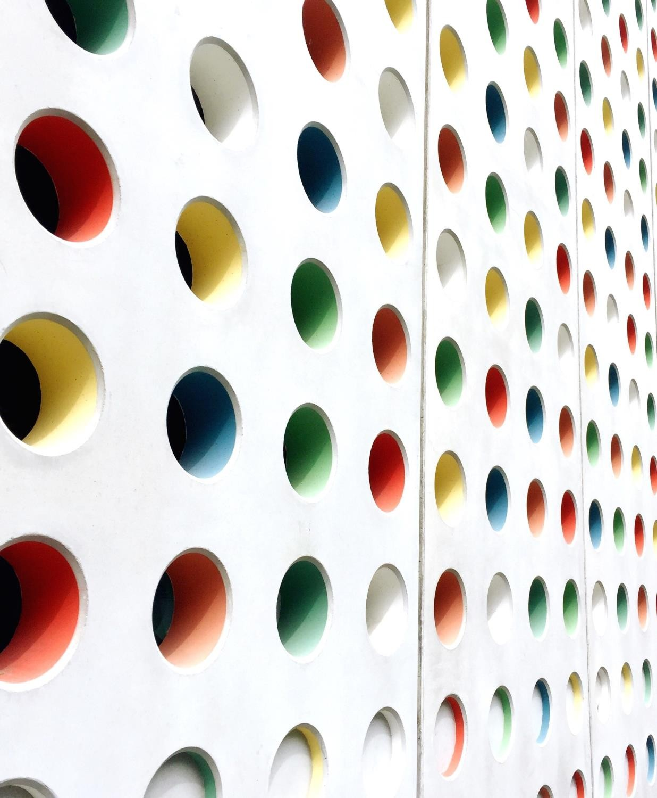

IBM ASSIGNMENT 1

***Raja Narayanan.P***

***960519205012***

IBM COGNOS ANALYTICS WITH WATSON

* STATE BY R&D SPEND
* ADMINISTRATION B Y R&D SPEND
* STATE BY R&D SPEND COLORED BY ADMINISTRATION
* MARKETING SPEND BY R&D SPEND COLORED BY ADMINISTRATION
* R&D SPEND SIZED BY ADMINISTRATION
* LINK TO OPEN MY DATA VISUALIZTION IN THE COGNOS ANALYTICS

# STATE BY R&D SPEND

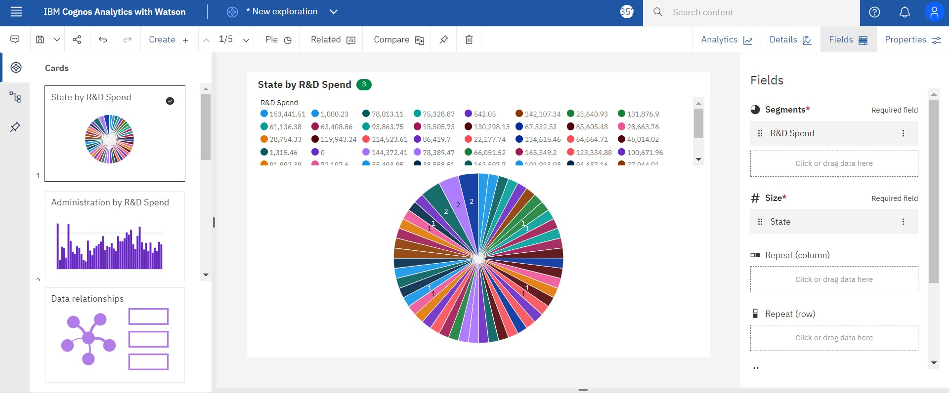

ADMINISTRATION B Y R&D SPEND

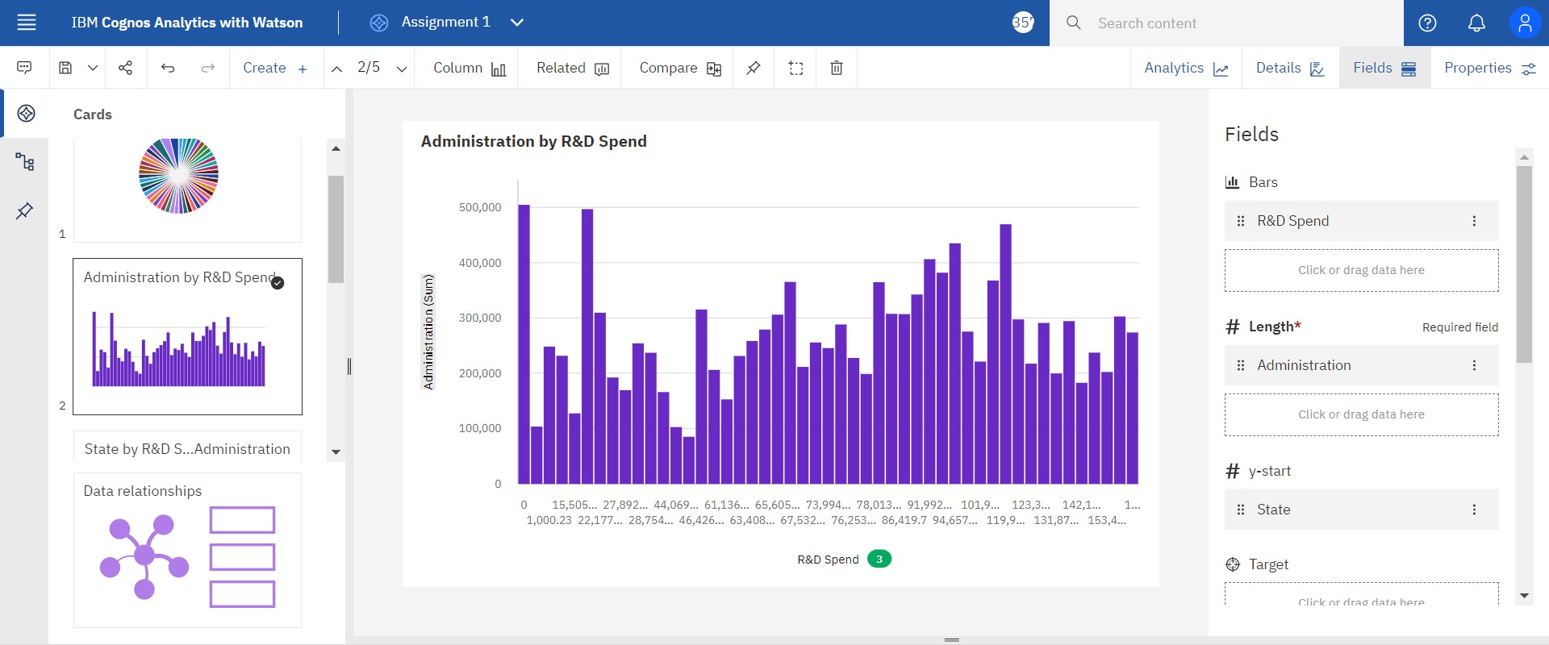

STATE BY R&D SPEND COLORED BY

ADMINISTRATION

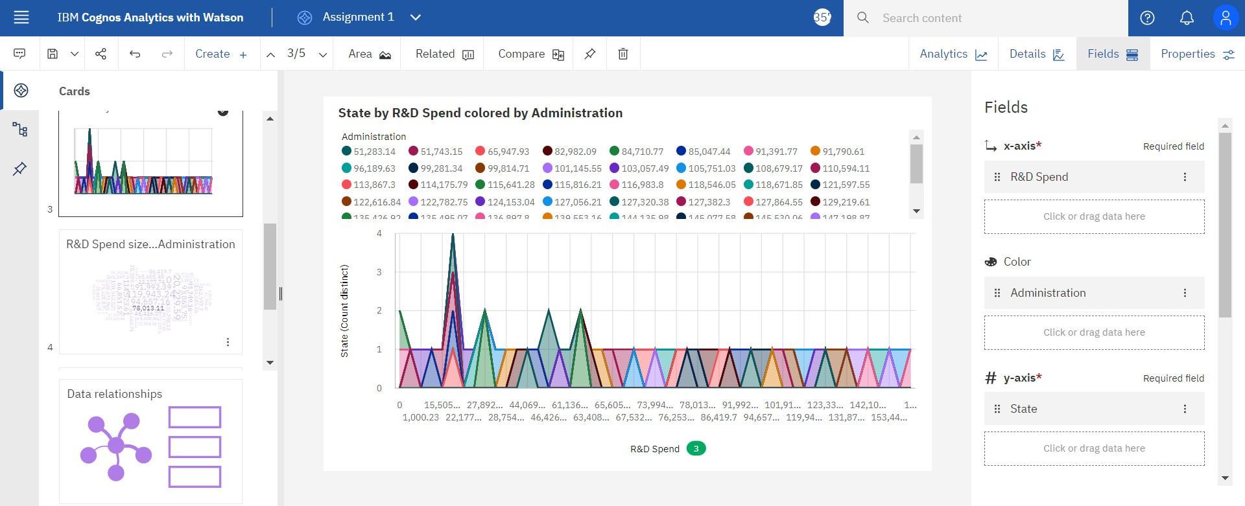

MARKETING SPEND BY R&D SPEND

COLORED BY ADMINISTRATION

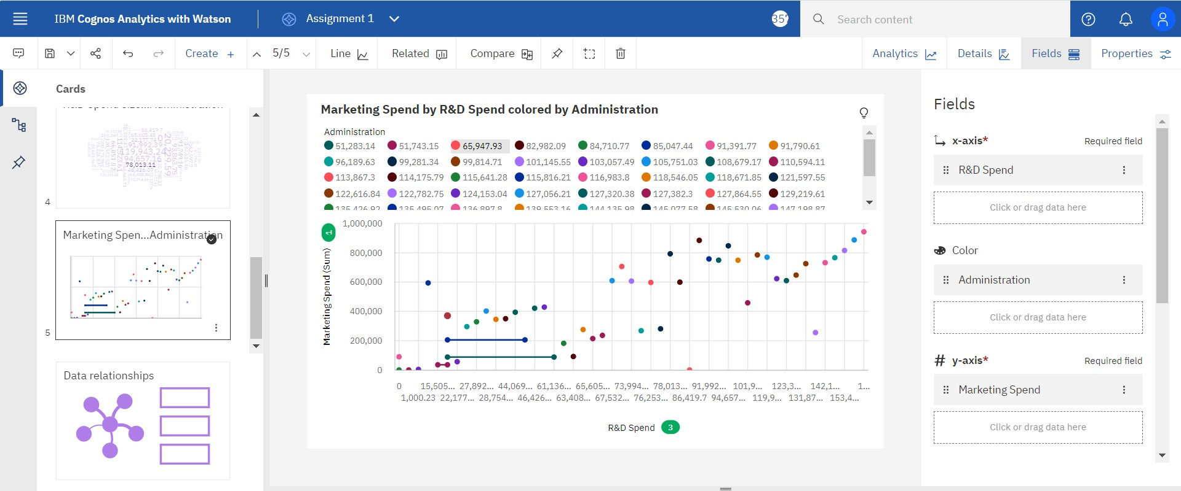

R&D SPEND SIZED BY

ADMINISTRATION

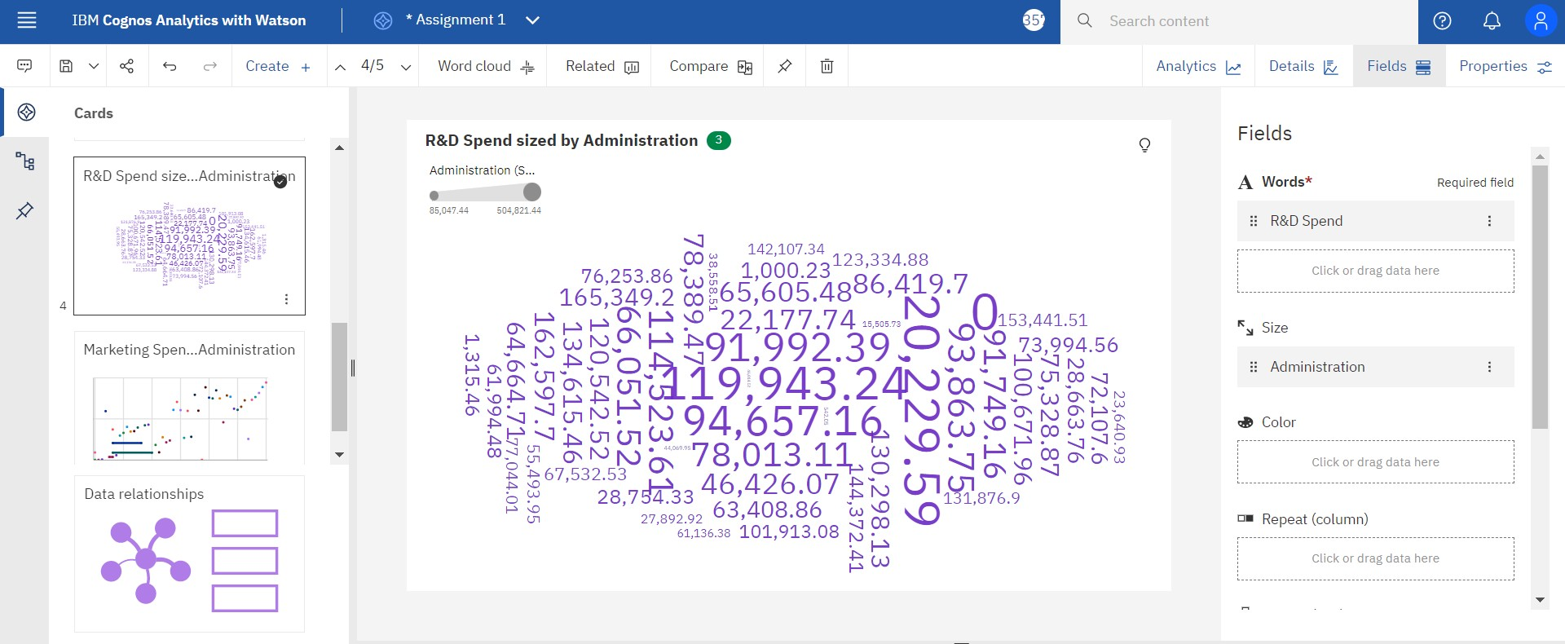

LINK TO OPEN MY DATA VISUALIZTION IN THE COGNOS ANALYTICS

## https://us3.ca.analytics.ibm.com/bi/?perspective=explore&pathRef=.my_folders%2 FData%2BExploration%2FAssignment%2B1&subView=model0000018345748ba0

_00000004